**Use case Diagram Help**  - **Tiago Francisco, nº60749**

This diagram describes the functionalities available in the help tab.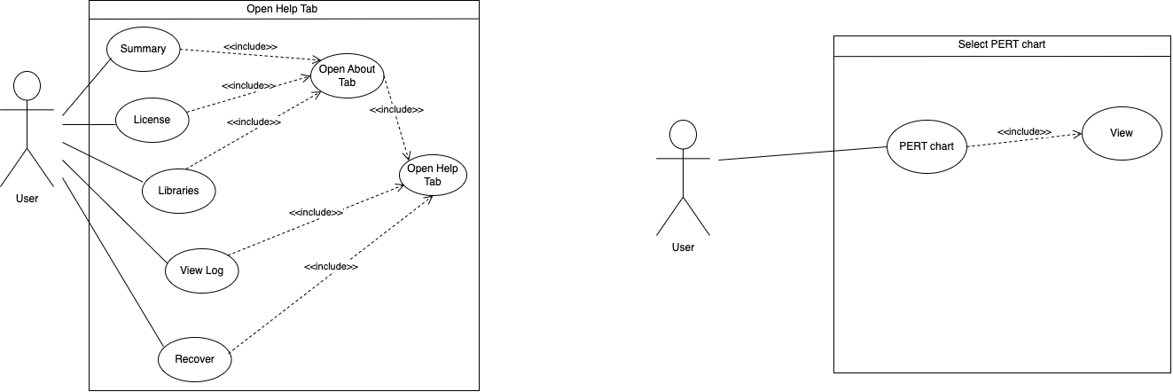

**Use case Diagram Select PERT chart** - **Tiago Francisco, nº60749**

This diagram describes how a user can make the PERT chart appear.